Test Case: tc006_SPX_Dev5_Crear_Requisicion_Spot_Tipo_Cobro_Proyect_Urgent
Step 1 - Enter username and password and click to button Enter: Credentials Entered
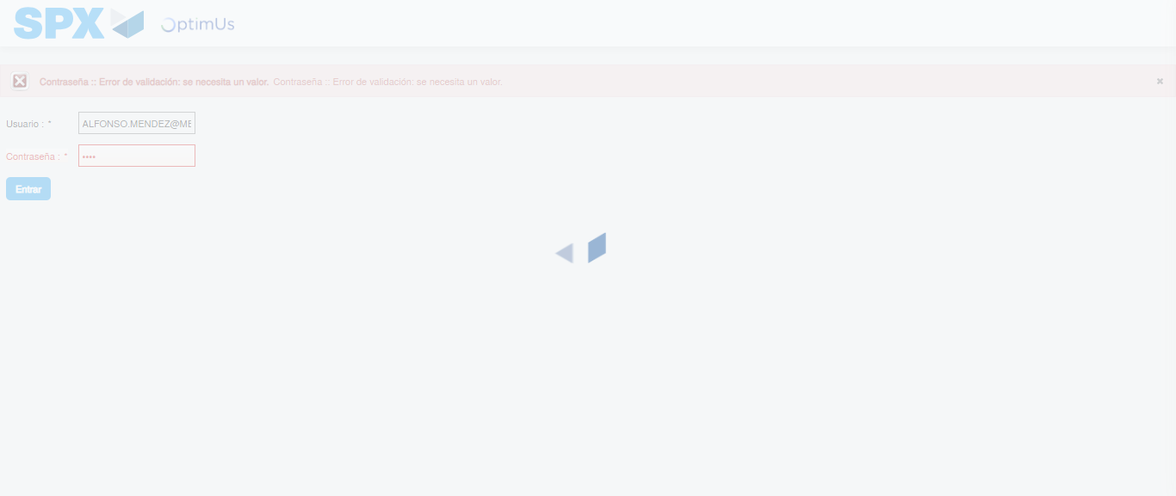Image file-name: QC_Testing-tc006_SPX_Dev5_Crear_Requisicion_Spot_Tipo_Cobro_Proyect_Urgent-1783373221463

Step 2 - Select to UEN and Access to Spot Buy Requisitions : UEN Correctly selected and Correct access
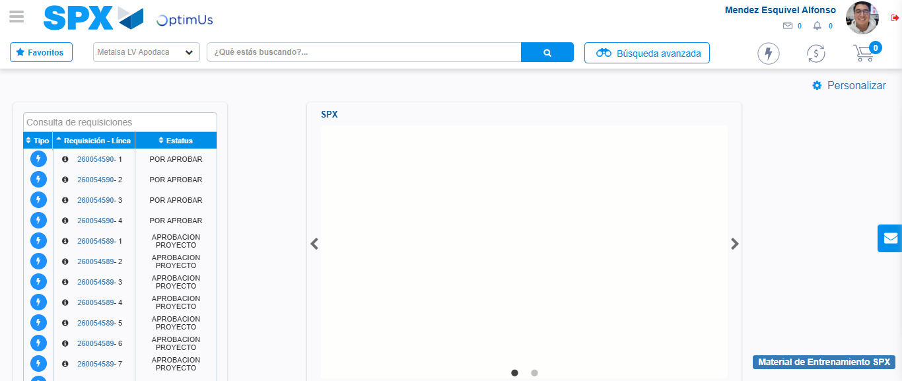Image file-name: QC_Testing-tc006_SPX_Dev5_Crear_Requisicion_Spot_Tipo_Cobro_Proyect_Urgent-1783373287750

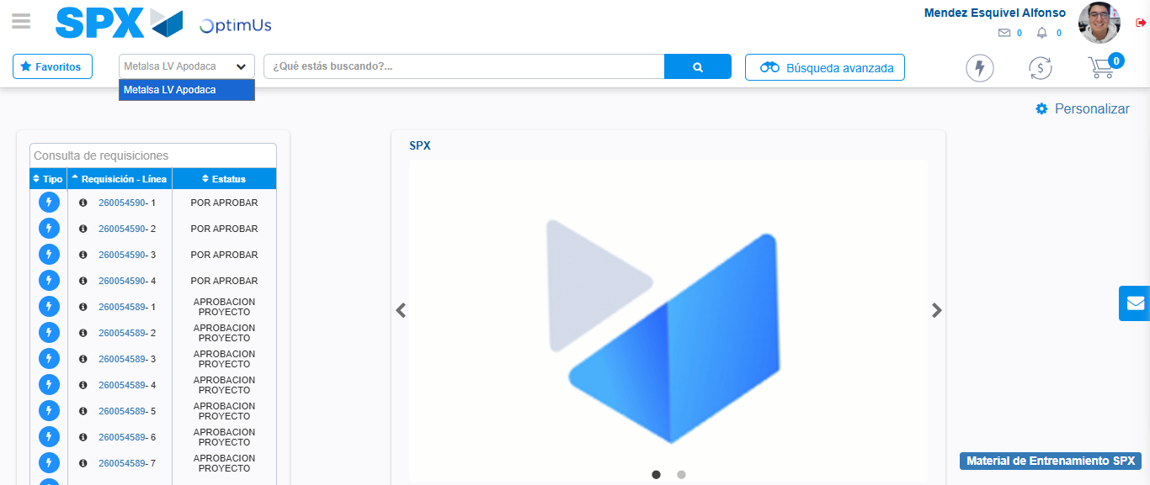Image file-name: QC_Testing-tc006_SPX_Dev5_Crear_Requisicion_Spot_Tipo_Cobro_Proyect_Urgent-1783373290448

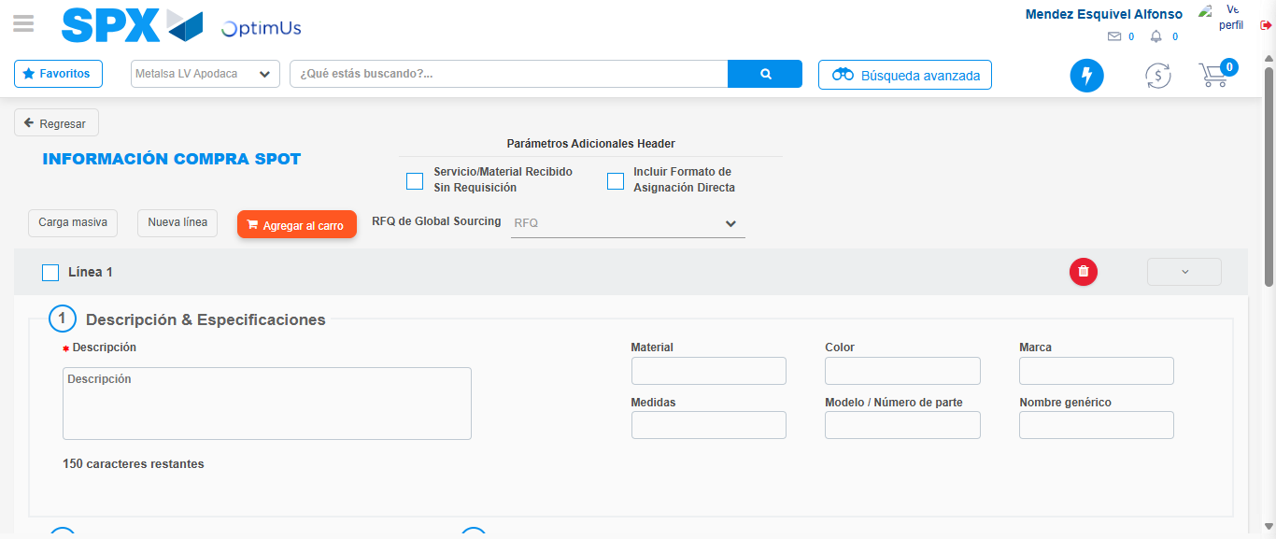Image file-name: QC_Testing-tc006_SPX_Dev5_Crear_Requisicion_Spot_Tipo_Cobro_Proyect_Urgent-1783373296776

Step 3 - Data Capture Spot Buy Requisition: Data captured correctly
Image file-name: QC_Testing-tc006_SPX_Dev5_Crear_Requisicion_Spot_Tipo_Cobro_Proyect_Urgent-1783373297012

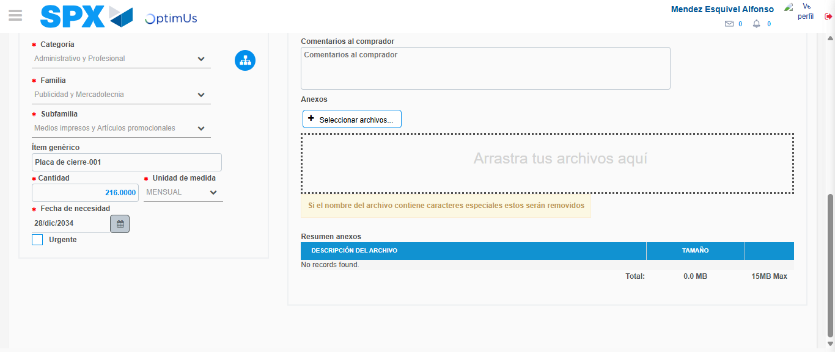Image file-name: QC_Testing-tc006_SPX_Dev5_Crear_Requisicion_Spot_Tipo_Cobro_Proyect_Urgent-1783373307057

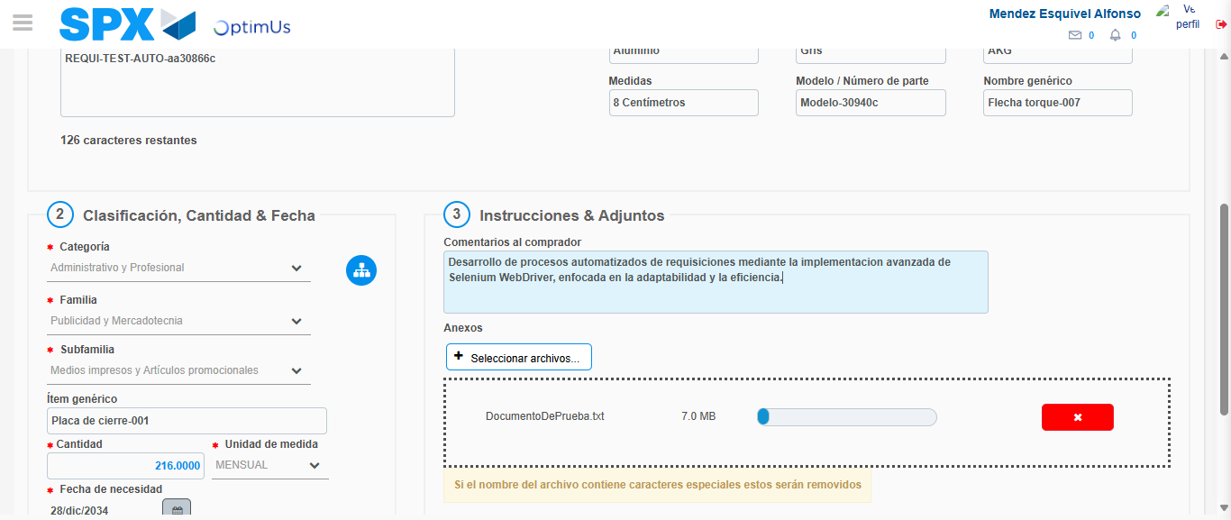Image file-name: QC_Testing-tc006_SPX_Dev5_Crear_Requisicion_Spot_Tipo_Cobro_Proyect_Urgent-1783373307814

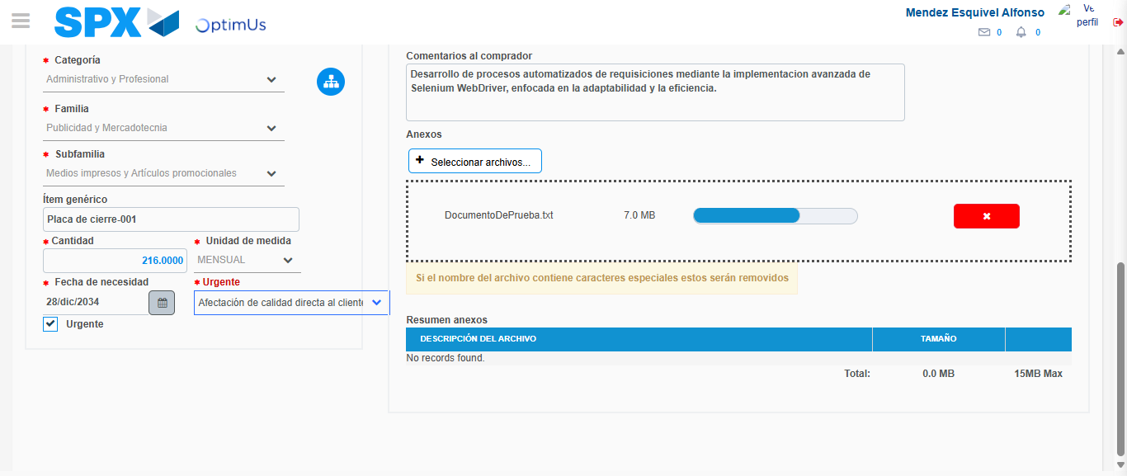Image file-name: QC_Testing-tc006_SPX_Dev5_Crear_Requisicion_Spot_Tipo_Cobro_Proyect_Urgent-1783373311551

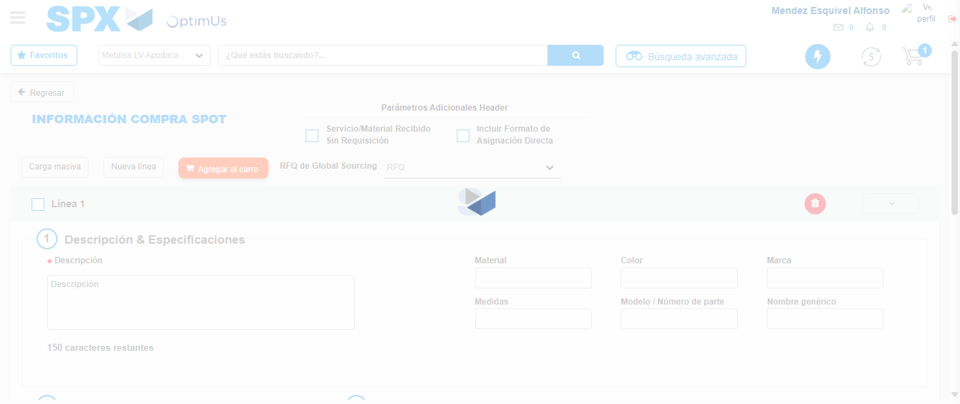Image file-name: QC_Testing-tc006_SPX_Dev5_Crear_Requisicion_Spot_Tipo_Cobro_Proyect_Urgent-1783373313463

Step 7 - Return to Main Page SPX : Return to Main Page SPX
Image file-name: QC_Testing-tc006_SPX_Dev5_Crear_Requisicion_Spot_Tipo_Cobro_Proyect_Urgent-1783373287750

Image file-name: QC_Testing-tc006_SPX_Dev5_Crear_Requisicion_Spot_Tipo_Cobro_Proyect_Urgent-1783373290448

Image file-name: QC_Testing-tc006_SPX_Dev5_Crear_Requisicion_Spot_Tipo_Cobro_Proyect_Urgent-1783373296776

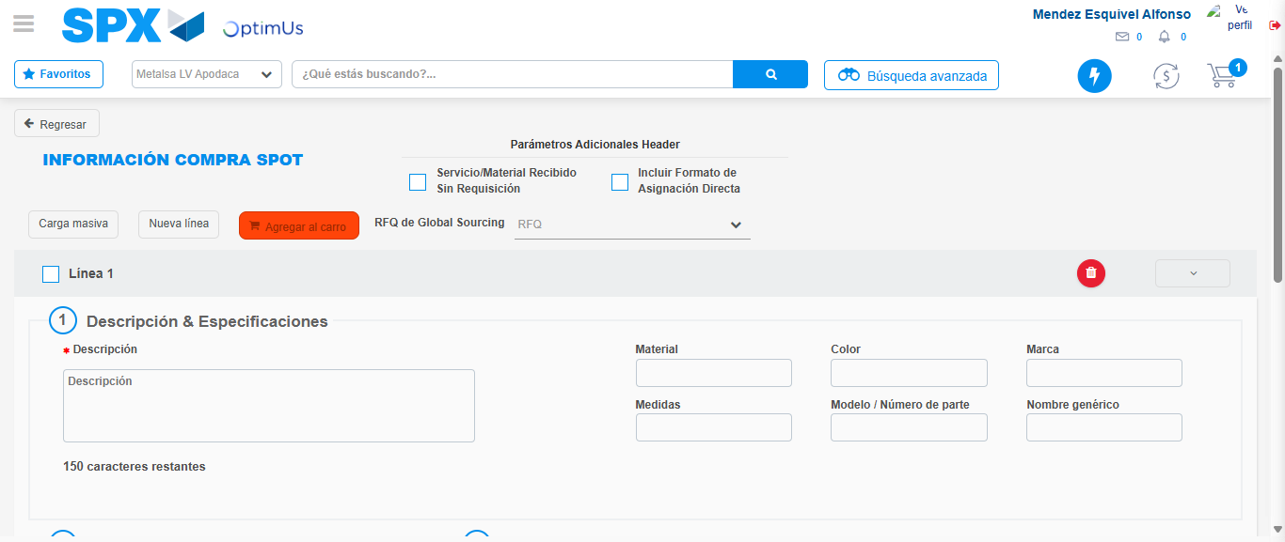Image file-name: QC_Testing-tc006_SPX_Dev5_Crear_Requisicion_Spot_Tipo_Cobro_Proyect_Urgent-1783373315668

Image file-name: QC_Testing-tc006_SPX_Dev5_Crear_Requisicion_Spot_Tipo_Cobro_Proyect_Urgent-1783373315850

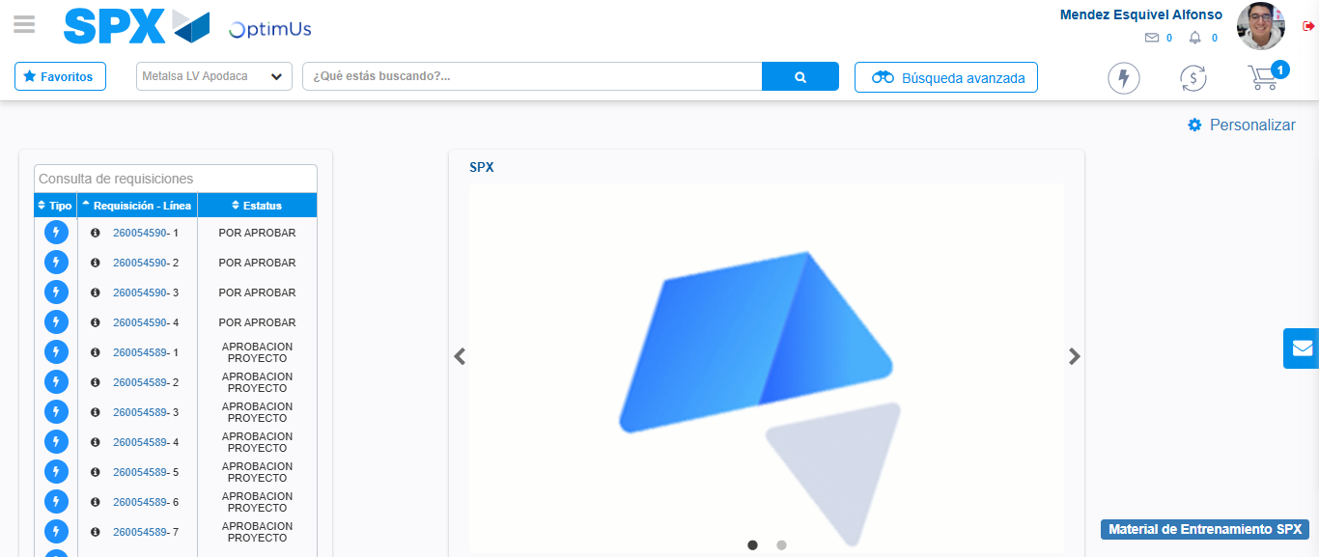Image file-name: QC_Testing-tc006_SPX_Dev5_Crear_Requisicion_Spot_Tipo_Cobro_Proyect_Urgent-1783373336993

Step 8 - Log Out : Log Out SPX
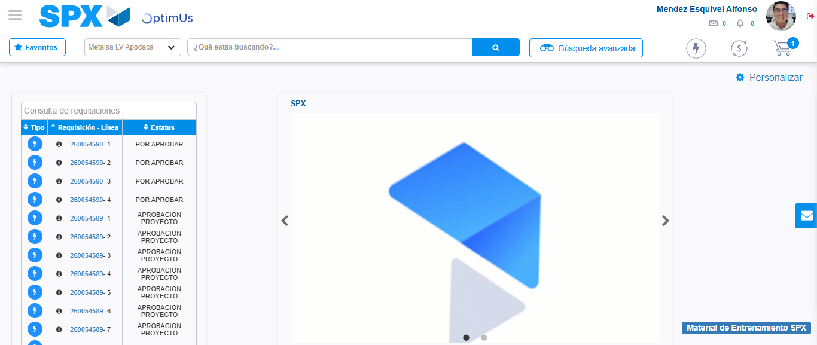Image file-name: QC_Testing-tc006_SPX_Dev5_Crear_Requisicion_Spot_Tipo_Cobro_Proyect_Urgent-1783373337195

